Question 12:
Make a dictionary of five cars and their manufacturing companies. Update one company.
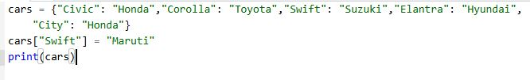
Output:
